Parallax Tilt
Pluggable widget for Mendix Studio Pro 10.24.17
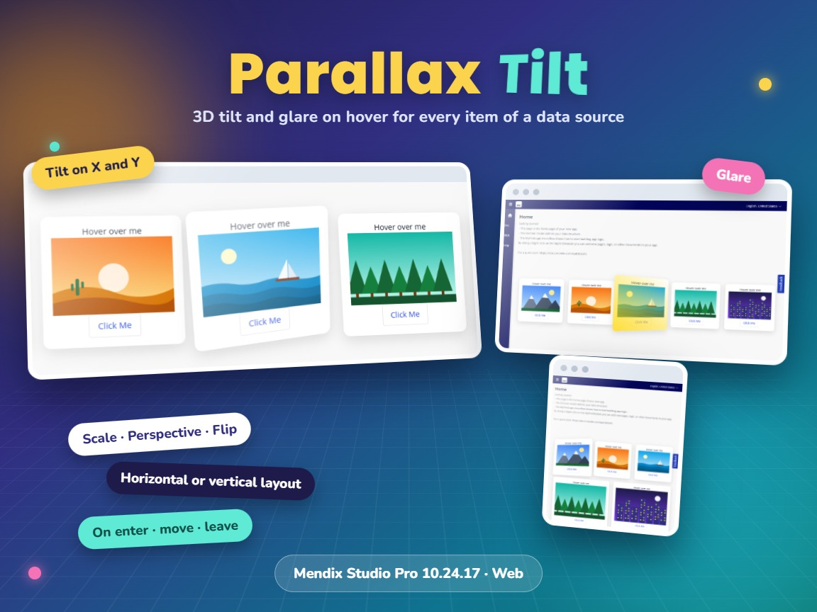
Item | Value
Widget version | 1.1.0
Studio Pro version | 10.24.17 (tested on 10.24.17.102810)
Widget ID | MxTechies.parallaxtilt.ParallaxTilt
Widget package | MxTechies.ParallaxTilt.mpk (about 17 KB)
Platform | Web (offline capable)
Tilt library | react-parallax-tilt 1.7.345
Build tooling | @mendix/pluggable-widgets-tools 10.16.0
Source and downloads | github.com/bharathidas/ParallaxTilt

Contents

1. Overview
Parallax Tilt shows each object of a data source as a card. When the mouse moves over a card, the card tilts in 3D towards the mouse, grows a little and shows a light reflection (glare). When the mouse leaves, the card returns to its place.
You design the content of a card in Studio Pro with any widgets: images, text, buttons. The tilt angles, glare, scale, perspective, speed and flip are set in the widget properties. Three events (enter, move, leave) can run an action.
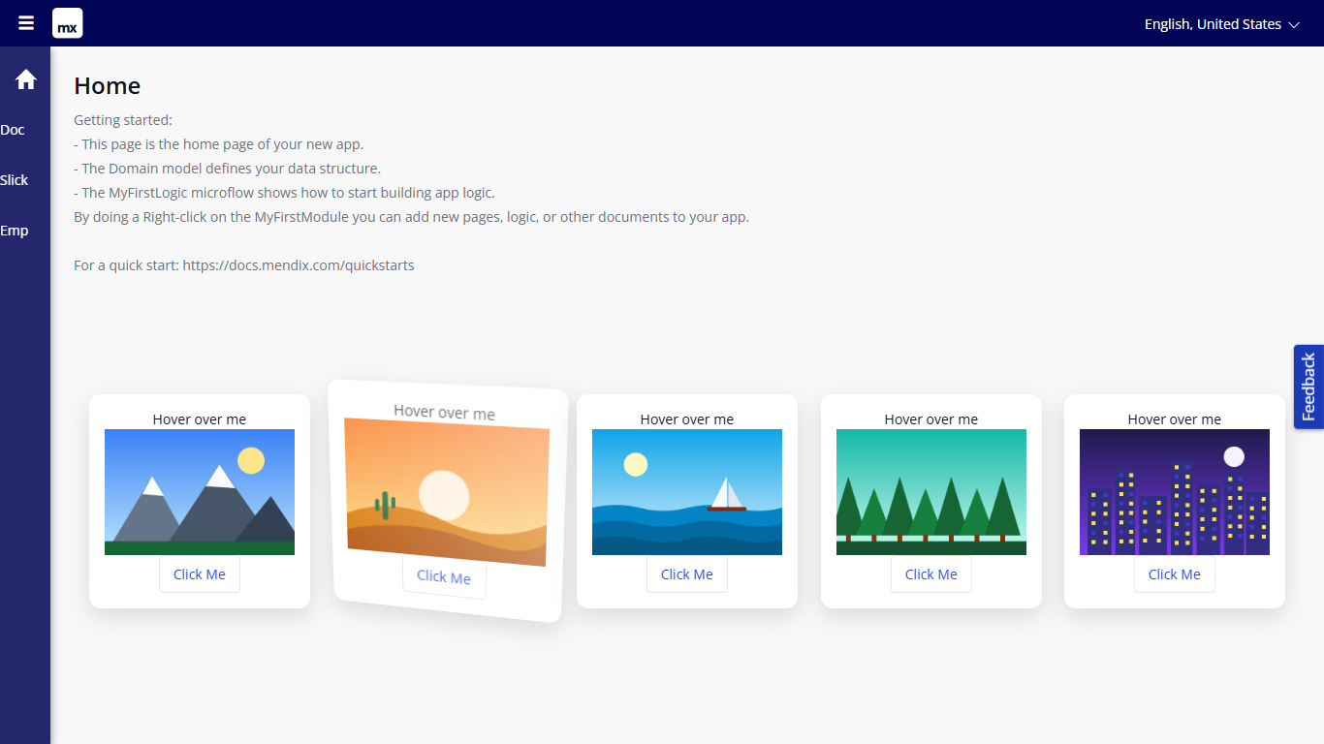
Figure 1. Five cards in a row; the second card tilts towards the mouse

Typical uses
- Product, offer or plan cards in a shop or portal
- Image galleries and portfolios
- Dashboard tiles and menu cards that react to the mouse
- Profile or team cards

2. What is new in version 1.1.0
- Rebuilt for Mendix Studio Pro 10.24.17 with @mendix/pluggable-widgets-tools 10.16.0, as a production build. The package is about 17 KB; version 1.0.0 was about 57 KB.
- Both tilt angles work in both orientations. In 1.0.0 the horizontal orientation used only Max tilt angle X and the vertical orientation only Max tilt angle Y; the other angle was ignored.
- The glare no longer stays fully visible when a card is not hovered. In 1.0.0 this happened in the vertical orientation with the glare positions top, bottom and all, and in the horizontal orientation with right, left and all, because the library divided by a tilt angle of 0. An angle of 0 is now handled, and the glare works with every position.
- Glare color, glare position and transition easing are optional and have defaults (#ffffff, top, cubic-bezier(.03,.98,.52,.99)). In 1.0.0 they were required. The glare position ignores case and spaces.
- Out-of-range values are limited: angles to 0–90, glare opacity to 0–1. A scale or perspective of 0 or less uses 1 and 1000.
- The CSS classes start with widget-parallaxtilt. In 1.0.0 the widget added global styles for the classes content and slide (white bold text), which could change other parts of the app.
- Horizontal cards share the width and wrap to the next line on small screens.
- The class and style from the Appearance tab are applied.
- The On move action does not start again while it is still running.
- Studio Pro design mode shows a card with a drop zone for the content. In 1.0.0 the preview was empty.
- Clearer captions and descriptions. The property keys are unchanged, so existing pages keep their settings.
Version 1.1.0 was tested in a Mendix 10.24.17 app (33 automated checks): both orientations, tilt on X and Y, angle 0, scale, perspective, glare color, position and opacity, tilt and glare off, flip, empty and out-of-range values, and wrapping on a narrow window. The screenshots in this document are from that test.

3. Requirements
- Mendix Studio Pro 10.24.17 or a later 10.24 version.
- A web profile. The widget is not available for native mobile.
- A data source with the objects to show as cards. No other modules are needed.

4. Installation

4.1 Install the widget
- Download MxTechies.ParallaxTilt.mpk from the Mendix Marketplace or from the GitHub release Version1.1.0.
- Copy the file into the widgets folder of your app. To find the folder, use App > Show App Directory in Explorer in Studio Pro.
- In Studio Pro, choose App > Synchronize App Directory (F4).
- The widget appears in the Toolbox as Parallax Tilt.

4.2 Upgrade from version 1.0.0
- Replace MxTechies.ParallaxTilt.mpk in the widgets folder with the 1.1.0 file.
- Synchronize the app directory (F4).
- Studio Pro reports that the widget definition has changed. Right-click the error and choose Update all widgets. Your settings are kept.
- If the running app still shows the old widget, stop it, choose App > Clean Deployment Directory, and run it again.
Check after upgrading: both tilt angles now apply. If you want the old one-axis tilt, set the other angle to 0 (horizontal in 1.0.0 = Max tilt angle Y 0; vertical in 1.0.0 = Max tilt angle X 0). If your theme styled the old classes tilt-container, content or slide, change it to the new classes in chapter 8.

5. Configuration

5.1 Place the widget on a page
- Drag Parallax Tilt from the Toolbox onto a page.
- On the General tab, select the Data source, for example an entity from the database, a microflow or an association.
- Drop the content of a card into the widget: for example an image, a text and a button. The content gets the object of the card as context.
- Choose the Orientation: horizontal (a row of cards) or vertical (a column).
- On the Configurations tab, adjust the effect. The defaults work well for most cards.
- Optional: on the Events tab, select actions for enter, move and leave.

5.2 Recommended settings
Effect | Settings
Subtle hover | Max tilt angle X and Y 10, scale 1.05, glare max opacity 0.3
Strong 3D | Max tilt angle X and Y 25, perspective 600, scale 1.15
Tilt only left and right | Max tilt angle X 0, Max tilt angle Y 20
Glare only, no tilt | Tilt enabled No (or both angles 0), glare enabled Yes
Coloured shine | Glare color rgb(255, 215, 0), glare position bottom, glare max opacity 0.9

6. Property reference

General
Property | Type | Description (default)
Orientation | Enumeration | Horizontal: cards in a row that wraps on small screens. Vertical: cards in a column. (Horizontal)
Data source | Data source | One card is shown for each object. Required.
Content | Widgets | Content of each card, with the object of the card as context. Required.

Configurations
Property | Type | Description (default)
Tilt enabled | Boolean | Turns the tilt on or off. Scale and glare still work when it is off. (Yes)
Max tilt angle X | Integer | Maximum rotation around the x-axis, when the mouse moves up and down, in degrees, 0–90. (20)
Max tilt angle Y | Integer | Maximum rotation around the y-axis, when the mouse moves left and right, in degrees, 0–90. (20)
Glare enabled | Boolean | Shows a light reflection that follows the mouse. (Yes)
Glare max opacity | Decimal | Maximum glare opacity, 0–1. (0.7)
Glare color | String | Any CSS color, for example #ffffff or rgb(255, 215, 0). Empty = white. (#ffffff)
Glare position | String | top, right, bottom, left or all: the side of the card that shines. Empty or unknown = top. (top)
Scale | Decimal | Size of the card while the mouse is over it: 1 = 100%, 1.1 = 110%. (1.1)
Perspective | Integer | Distance to the card in pixels. Lower values give a stronger 3D effect. (1000)
Transition easing | String | CSS easing of the movement, for example ease-out. Empty = default. (cubic-bezier(.03,.98,.52,.99))
Transition speed | Integer | Duration of the movement in milliseconds. (1000)
Flip vertically | Boolean | Shows the cards upside down (180° around the x-axis). (No)
Flip horizontally | Boolean | Shows the cards mirrored (180° around the y-axis). (No)

Events
Property | Type | Description
On enter action | Action | Runs when the mouse enters a card.
On move action | Action | Runs while the mouse moves over a card. It runs very often; a run that is still busy is not started again. Use a light nanoflow.
On leave action | Action | Runs when the mouse leaves a card.

The actions belong to the widget, not to a card: they do not receive the object of the card. To act on a card's object, use a button or an On click action inside the card content.

7. Examples
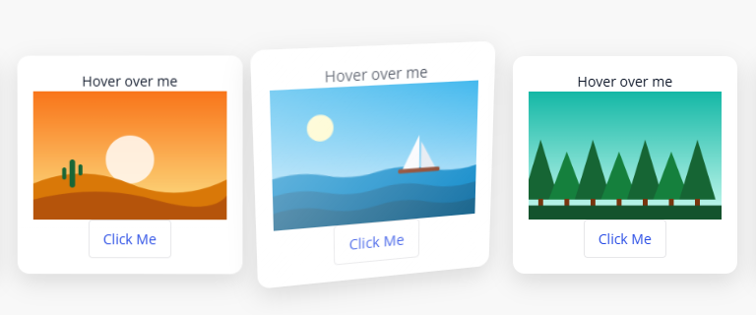
Figure 2. Default settings: the card tilts on both axes and the glare shines from the top
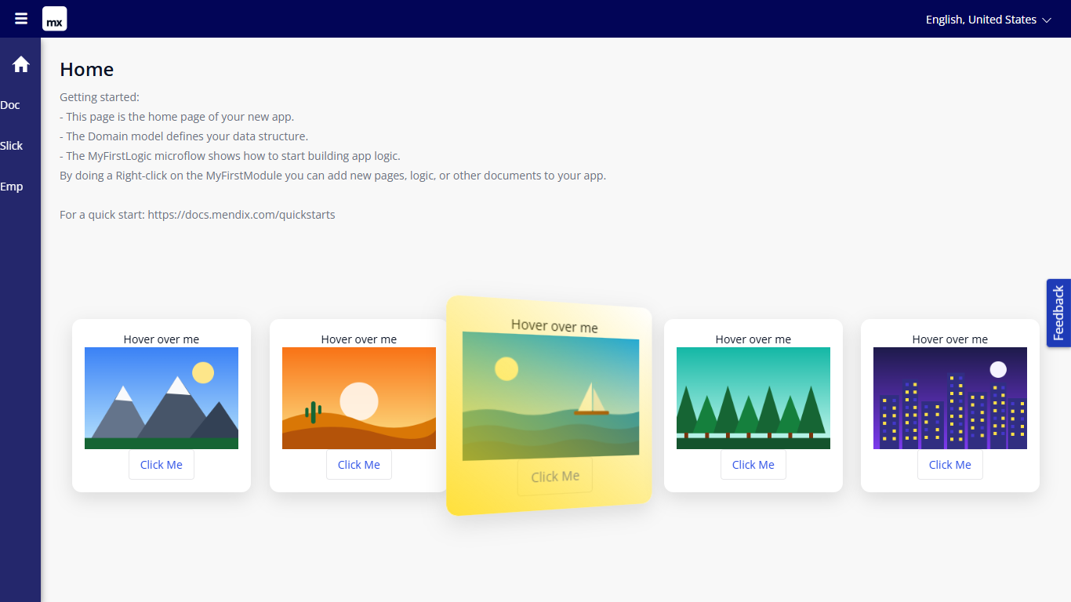
Figure 3. Max tilt angle X 0, angle Y 25, scale 1.2, perspective 600, gold glare at the bottom
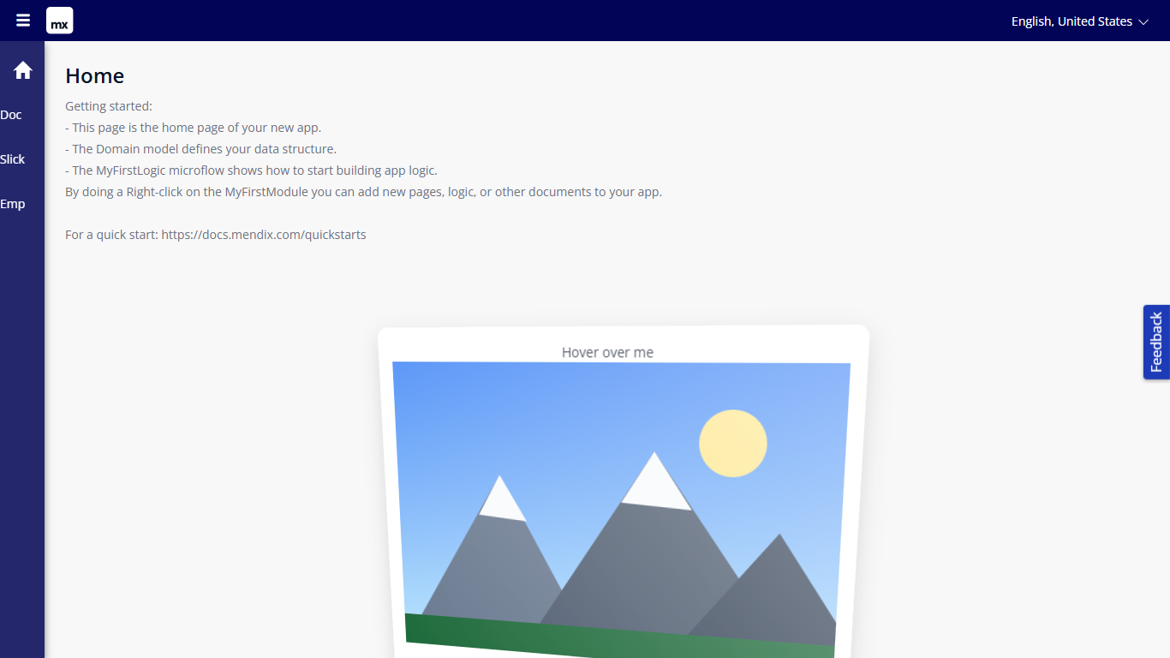
Figure 4. Vertical orientation with glare position all
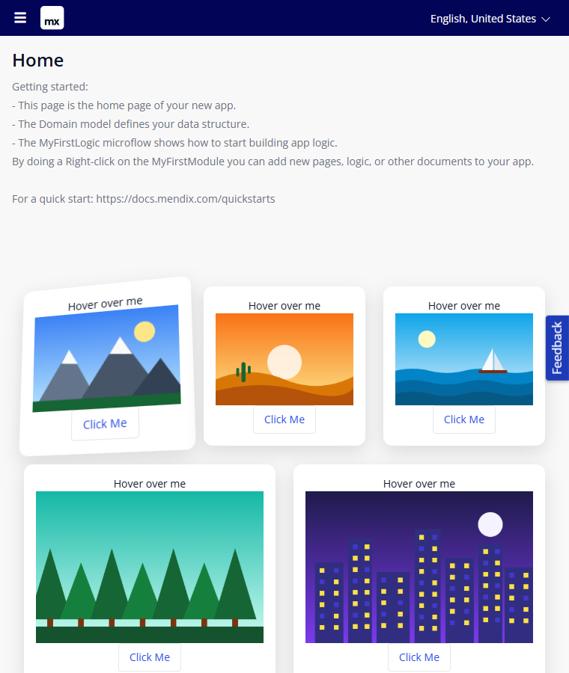
Figure 5. Horizontal orientation on a narrow window: the cards wrap
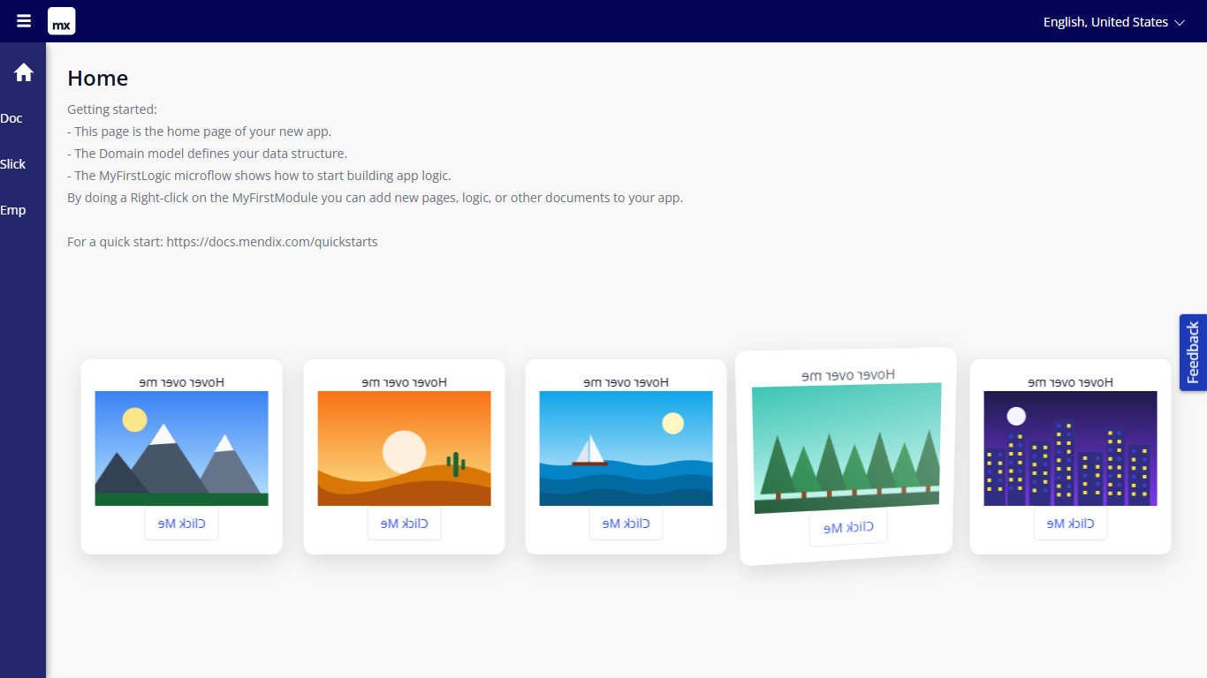
Figure 6. Flip horizontally: the cards are mirrored and still tilt

8. Styling
The widget renders these elements. The class and style from the Appearance tab are applied to the outer element.
<div class="widget-parallaxtilt widget-parallaxtilt-horizontal your-class">
<div class="widget-parallaxtilt-card">
<div class="widget-parallaxtilt-content"> your content </div>
<div class="glare-wrapper"><div class="glare"></div></div>
</div>
... one card per object ...
</div>
The second class is widget-parallaxtilt-horizontal or widget-parallaxtilt-vertical. Examples for your theme:
/* Fixed card width in the horizontal row */
.widget-parallaxtilt-horizontal > .widget-parallaxtilt-card { flex: 0 0 260px; }

/* Dark cards without padding */
.widget-parallaxtilt-card { background-color: #1e1b4b; color: #fff; }
.widget-parallaxtilt-content { padding: 0; }

9. Known behaviour and limitations
- The effect follows the mouse pointer. Touch screens have no hover, so on phones and tablets the effect is limited.
- The events run for the widget; they do not get the object of the card.
- Glare position and transition easing are text properties; an unknown glare position uses top, and an invalid easing is ignored by the browser.
- Very large angles (more than about 60 degrees) can turn a card so far that the mouse leaves it, and the card returns to rest.
- Web only; not available in native mobile apps.

10. Support and version history
Report issues, suggestions and feature requests on GitHub:
https://github.com/bharathidas/ParallaxTilt/issues
Source code and all releases:
https://github.com/bharathidas/ParallaxTilt
Widget | Studio Pro | GitHub release | Changes
1.1.0 | 10.24.17 | Version1.1.0 | Rebuilt for Studio Pro 10.24.17; both angles in both orientations; glare no longer stuck at full opacity; optional glare color, position and easing; value limits; scoped CSS classes; wrapping row; class and style applied; design-mode preview.
1.0.0 | 10.18.3 | Version1.0.0 | First release.

